**Leader Overview**



**Volume Overview**

**Navigate Hardship**

*Life is hard, even for believers. We all know it or discover it soon enough. Life tests our patience, our hope, and our sense of God’s presence. But we are not left hopeless in our challenges. God’s presence is more certain than even our hardships. Still, there are times in life that we need to be reminded that He is present. It’s in hardships that we learn to recognize it. We also learn to depend on God, to wait, and to look forward to His rescue.*

**Session Overview**

**Look Forward**

*In this* **Live** *session, kids will discover that God will lead them, even in the midst of their struggles, confusion, or difficulty. When the father of a sick boy asked Jesus to heal his son, Jesus’ instructions surprised the dad, but he chose to trust and follow what Jesus said. Knowing that God is leading us through our hardships gives us someone to depend on. As we trust and follow God’s lead, we can look forward to the future God has for us.*

**Bible Lesson**

A Father’s Journey for His Son’s Healing

[John 4:43–54](https://ref.ly/logosref/Bible.Jn4.43-54)

**Faith Fact**

I can trust God to lead me.

**Faith Verse**

[Psalm 34:19](https://ref.ly/logosref/Bible.Ps34.19) (NLT)

The righteous person faces many troubles, but the Lord comes to the rescue each time.

**Preparing for the Session**

**Leader Preparation Time: 20–25 Minutes**

|  |
| --- |
| ***You Will Need***  ***Large Group***   * *Bible* * *Worship songs (Song suggestions: “Nothing is Impossible” Lyric Video by Planetshakers; “Only Wanna Sing” Lyric Video by Hillsong Young & Free: “Trust” Lyric Video by Hillsong Young and Free, “Surrounded (Fight My Battles)” Lyric Video by Upper Room)* * *For groups not using a phone or tablet only, add:*   *• Projector or TV*  *• Laptop*  *•* ***Faith Fact Slide***  *•* ***Faith Verse Video*** *or* ***Slide***  *•* ***Bible Lesson Video***  *•* ***Teaching Point Slides 1–3***  *•* ***Teaching Time Slides A–E***  ***Small Group***   * ***Small Group Group Connection Pages 1 & 2****, one set per two kids* * *Copy paper, one sheet per kid* * *Pencils or markers, one per kid* * *Bibles for kids in the group to share* * ***Small Group Activity Page****, one per kid* * ***Small Group Activity Page Answer Page****, if needed* * *Pencils or pens, one per kid* * *Crayons or markers*   *To access session content and videos from a computer, visit:* [*BibleEngagementProject.com/downloads*](https://bibleengagementproject.com/downloads) |
| ***Getting Ready***  ***Large Group***   * *Download videos and slides if needed.* * *Select worship song(s) and have them ready to play.* * *Read the Bible Lesson Scripture to prepare for Teaching Time.* * *Before the session begins, choose 1–3 kids and tell them to deliberately not follow your instructions in the Game. They are to do their own thing while pretending to follow your instructions.* * *Before the session begins, choose 1–3 other kids and tell them to talk loudly and interrupt during the Game. They are trying to distract the group from hearing you give instructions.* * *Review the Teaching Time Slides A–E so you understand the optical illusion.*   ***Small Group***   * *Print copies of the* ***Small Group Group Connection Pages 1 & 2****, one set per two kids.* * *Cut the* ***Small Group Group Connection Page*** *in half.* * *Print copies of the* ***Small Group Activity Page****, one per kid.* * *Print the* ***Small Group Activity Page Answer Page****, if needed.*   *First time leading* Live *for Kids? Check out the* [*Facilitator Guide*](https://0b769b0ed3569ef9d18b-f88d8272f61086866d50d048b43ef630.ssl.cf2.rackcdn.com/sites/biblengagementproject/Listen_Facilitator_Guide.pdf)*.* |

**Large Group**

**30 Minutes**

*See what’s needed at the beginning of the session.*

**Introduction**

I’m so excited that we get to spend some time together today! We’ll talk about what to do when we go through difficult or challenging times. How many of you wish that you would never have to face anything hard for the rest of your life? *(Group response)* That would be amazing, right? But we know that difficulties will come. Our Faith Verse, [Psalm 34:19](https://ref.ly/logosref/Bible.Ps34.19), tells us that. That’s why it’s important to know how God leads us in the middle of tough times. Raise your hand if you’re ready to learn more about that today. *(Group response)*

It would be one thing if we had to face our troubles all by ourself. But that’s not the case. When Jesus is our Savior, we have God leading us through life’s challenges. If we have God on our side, then we can have peace in the face of any difficulty.

Has anyone here ever been lost? *(Group response)* Maybe you wandered off in a store or followed someone who led you in the wrong direction. How does it feel when you’re lost? *(Allow responses.)* We can get scared, extremely frustrated, and anxious.

• *Share a personal story about you or someone close to you getting lost.*

• *If you can’t think of a story, make up one about a kid getting lost in a store where there are lots of different aisles. Talk how it would have felt to be looking at something and then to look up and not see your parent.*

As we learn to follow God and let Him lead us, we can be confident that He is with us even in the most difficult places. We’ll see in our Bible story that God sometimes gives us surprising instructions, but He will lead us in the right way every time. We just need to decide to trust and follow Him.

**Faith Fact**

This reminds me of our Faith Fact for today: **I can trust God to lead me.**

• *Show the* ***Faith Fact Slide.***



In our Bible story, a father had to trust that Jesus led him in the right direction when the man’s son was very sick. Trusting God can be hard because we don’t see Him face-to-face like the father in the story saw Jesus. God lets us choose to follow Him or not. We won’t always know why He wants us to do what He tells us to do. That’s where trusting Him comes in. How many of you want to get better at trusting God? *(Group response)* Point up to the sky, march in place, and say the Faith Fact. **I can trust God to lead me.** Let’s say it one more time. **I can trust God to lead me.** That was great!

**Game**

**Listen Well**

Let’s see how well we can all follow directions. All you need to do is to listen and follow everything I say. I will give you instructions, and you must do everything just as I say. If you miss an instruction or mess up, catch up on the next instruction. Let’s play.

• *As you give instructions, say them only once and say them faster and faster.*

* Touch your nose with your right index finger.
* While touching your nose, use your left hand to tap the top of your head three times.
* Now lift your right leg and put it down as you shout your favorite color and number.
* Place your right hand on your left ear. Then shout out the month of your birthday.
* Put your left foot in front of your right foot.
* Slide your left hand down your left leg and touch your knee.
* Spin around in a circle one time and say, “Whee!”
* Turn around as you shout out your favorite meal.
* Sit down and then stand up.
* Turn around and take off your left shoe.
* Jump up three times and shout out one thing you love.
* Lift your right leg and grab it with your left hand as you shout your name.
* Shout out the names of your siblings and pets as you clap your hands seven times.

Wow! Those were a lot of instructions. How many of you had a hard time following everything? *(Group response)* What made following these directions difficult? *(Allow responses.)*

In this game, you had to listen and act at the same time. Sometimes others were doing things incorrectly or talking while I was giving instructions. Maybe you missed certain instructions and got frustrated or felt like giving up. Life can be like this. As we follow God, He will give us instructions to follow to make our life better.

At the same time, there may be people who are trying to get us off course. They may say things that are the opposite of what God is saying to us or what we’ve learned from the Bible. It’s important that we do our best to continue listening to God and following Him to move forward regardless of how hard it may be to do that.

With God’s help, we can get better at listening to His direction and being led by Him. Remember our Faith Fact. **I can trust God to lead me.** Let’s say the Faith Fact together. **I can trust God to lead me.**

**Worship**

When we worship God, we can open our heart and mind to what God might be speaking to us. Sometimes, God might give you some special instructions in your mind or speak to your heart while you worship. He can lead us when we open our heart and mind like this. Who is ready to worship God today? *(Group response)* Let’s worship Him by singing together.

• *Lead the kids in singing one or two praise songs. See suggestions at the beginning of the session.*

**Bible Lesson**

I’m so glad we had time for worshipping God together! Worshipping God helps us trust Him more and prepares our heart and mind to follow His lead. Remember our Faith Fact. **I can trust God to lead me.** We’ll hear what the Bible says about a father who chose to trust Jesus’ lead before he could see or know the end result. That’s not easy to do. Let’s pray before we begin.

**Prayer**

|  |
| --- |
| *Dear God, thank You for wanting to lead each of us through every moment of every day. Help us to hear from You clearly as we open Your Word and learn about others who were led by You. In Jesus’ name. Amen.* |

**Video Intro**

Just before we look at the Bible story, let’s watch this video.

• *Play* ***Bible Lesson Video***.



**Bible Story**

**A Father’s Journey for His Son’s Healing**

Have you ever felt like God told you to do something like Isa did? *(Group response)* Sometimes His direction can be very clear and easy to do, such as picking up someone’s books when they dropped their books. Other times, God’s directions can be challenging, such as being kind to someone who is always mean to you. Trusting God to lead us can be tough. Our Bible story today was about a man who really needed help from Jesus.

**Teaching Time**

So, Jesus was doing what He had come to earth to do—sharing the good news, restoring people’s lives, and teaching them about God’s love. What do you think the people thought about Jesus? *(Allow responses.)* Everywhere Jesus went, many people were amazed by what He did, how He taught them, and the person He was. Many people liked Jesus, but others didn’t like Him at all. That’s kind of surprising since He was God’s Son.

Many who liked Jesus saw that He had God’s power and used it to help others. Those who didn’t like Jesus thought He wasn’t working for God at all. Some even believed He was trying to take away their power. They were often people in charge who didn’t want anyone else to lead. Either way, a lot of people knew about Jesus.

Just before our Bible story began, Jesus had been traveling from city to city. Then, He ended up going back to Cana, the city where He had done His first miracle. There was a man who was a government official in a nearby town. He was probably powerful and had a lot of authority. While some leaders didn’t like Jesus, this man had a big problem, and he needed Jesus’ help. Let’s find out how willing this official was to be led by Jesus in an unexpected way.

Grab your Bible or pull up a Bible app on your device. Turn to [John 4:43–54](https://ref.ly/logosref/Bible.Jn4.43-54).

• *In order to keep Large Group time moving along, we recommend that the leader reads the Scripture portions aloud.*

• *Optional: Remind the kids to mark this place with a bookmark, so they can read it on their own at home.*

**The official begged Jesus to heal his son.**

• *Show the* ***Teaching Point 1 Slide.***

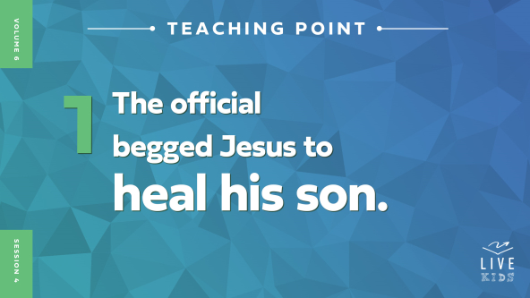

• *Read* [*John 4:43–47*](https://ref.ly/logosref/Bible.Jn4.43-47).

The government official had a big need. What was it? *(Allow responses.)* His son was very sick. He decided he needed to walk down the road to another city to see if Jesus would help him.

• *Show the* ***Teaching Time Slide A.***



Why do you think this official traveled so far to beg Jesus to heal his sick son? *(Allow responses.)* Remember, in this time they didn’t have hospitals, effective medicine, and doctors like we do now. Maybe the dad felt he had no other options. Maybe he needed help quickly, and he knew that Jesus was the only way his son could be healed. We don’t know for sure, but the official left his sick son at home and traveled to the town where Jesus was staying.

• *Show the* ***Teaching Time Slide B.***

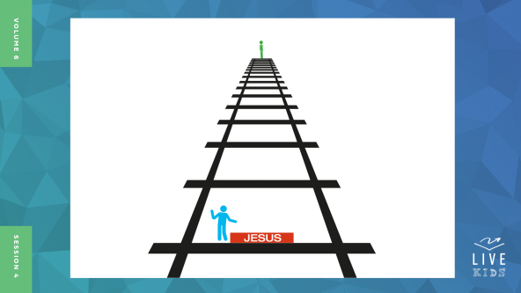

The man already knew that Jesus could do things that seemed impossible. He begged Jesus to come to his home to pray for his son and heal him. Do you think Jesus went with him? *(Group response)* Let’s find out!

**Jesus challenged the father’s faith.**

• *Show the* ***Teaching Point 2 Slide.***



• *Read* [*John 4:48–50*](https://ref.ly/logosref/Bible.Jn4.48-50)*.*

Wow! Jesus often went to sick people when they needed healing, but not this time. Instead, Jesus told the man that his son would live, so he should go home. Are you surprised Jesus didn’t go to the boy and pray for him like his father asked? *(Group response)*

Have you ever asked an adult for help with something, but they told you to do it on your own? Raise your hand. *(Group response)* How did that make you feel? *(Allow responses.)* Sometimes when that happens, we might feel that our problem isn’t very important to others. What’s a big problem to us is a small problem to them. Sometimes we can even feel that way about Jesus and wonder if He really cares about our problems. We don’t know how the father felt on the inside, but we can see how he responded to Jesus. The Bible says that he believed what Jesus told him.

It might have been really hard for the father to leave and start walking back toward home and his sick son without Jesus. He must have really trusted in Jesus to leave without Him. This man’s faith shows us how to trust God while we’re waiting. He knew that even if what happened when he was with Jesus was different from what Jesus did for someone else, it would be okay. Even if it meant his son’s healing was delayed, he was willing to follow what Jesus told him to do—go back home. Step by step he trusted Jesus to lead him.

• *Show the* ***Teaching Time Slide C.***

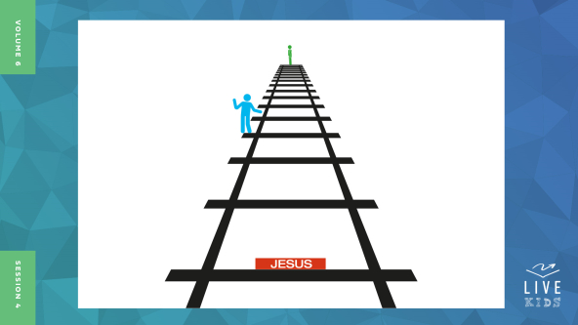

The father had a lot of time to think while he walked back home to his sick son without Jesus. As he got closer to home, he probably wondered how his son was doing. Sometimes when we focus on our problem, Jesus seems to get smaller and farther away just like in this picture.

Do you think you would have trusted Jesus like this father did? *(Group response)* The father may have had some questions or doubts in his mind, but he trusted Jesus more than his doubts. What happened next probably won’t be a huge surprise because Jesus always keeps His promises.

**Jesus’ words came true.**

• *Show the* ***Teaching Point 3 Slide.***



• *Read* [*John 4:51–54*](https://ref.ly/logosref/Bible.Jn4.51-54).

What did Jesus say about the sick boy before He sent the father home? *(Allow responses.)* Did Jesus’ words come true? *(Allow responses.)* Yes! Before the man could even make it back to his sick son, some of his servants ran to him and said that the boy had been healed. His dad figured out that his son was healed at the exact time that Jesus had said the boy would live.

Can you imagine the relief that this dad felt? *(Group response)* He not only had the faith to ask Jesus to do something incredible, but he also got to see Jesus honor His word. Even though Jesus wasn’t there in person, Jesus’ power to heal was right there with the official’s sick son.

• *Show the* ***Teaching Time Slide D.***

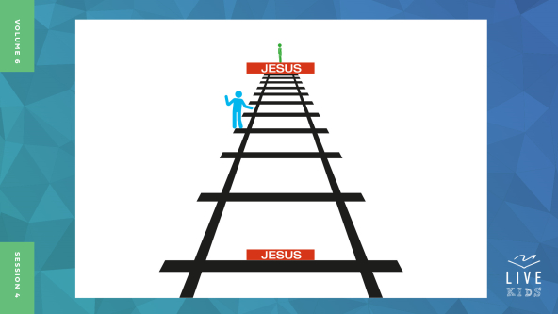

Jesus didn’t need to go and pray for the boy. This man discovered that Jesus was exactly who He said He was no matter how near or far away He seemed. The dad realized that Jesus cared as much about his sick son as he did.

The man in our Bible story shows us just how important it is to trust Jesus and follow His lead. Jesus proved himself to be trustworthy and He did what He had said He would do.

Trusting God to lead us can be challenging. Examples like this in the Bible remind us that God cares about what we’re going through. Sometimes the more we focus on our big problems, the smaller God seems. The truth is that God is always the same.

• *Show the* ***Teaching Time Slide E.***

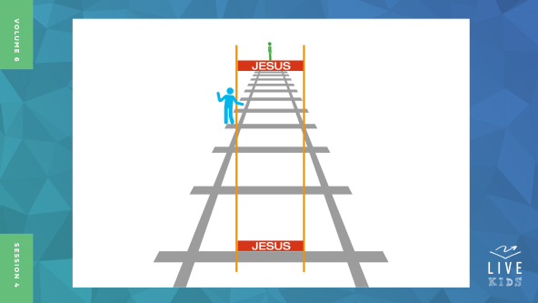

The more we trust God to help us, the smaller our problems seem and the bigger God seems in comparison. As we see how faithful and powerful He is, we can trust Him to lead us more and more. That’s why we should always remember this Faith Fact. **I can trust God to lead me.**

**Prayer and Response**

*Consider playing a worship song softly in the background while kids pray.*

Look at your own life and think about a big need you have. Let’s ask God to help us with those needs we have right now. He is so much closer and bigger than our needs. He will help us trust Him to lead us step-by-step. Take a few minutes to pray about the problem you or someone you love is facing. Then, I’ll close in prayer.

• *Give kids time to pray.*

**Prayer**

*Optional: Have the kids repeat phrases of the prayer after you.*

|  |
| --- |
| *Dear God, thank You for leading me in a way I can trust, even if I don’t always know what every detail will look like. Help me to trust You more and more each day. Don’t let me be afraid to ask for You to show up in my life in amazing and powerful ways. In Jesus’ name. Amen.* |

**Faith Verse**

Our Faith Verse reminds us that God wants to rescue us every time we face difficult things. We can always trust He is with us.

• *Play* ***Faith Verse Video***.



[Psalm 34:19](https://ref.ly/logosref/Bible.Ps34.19) (NLT)

The righteous person faces many troubles, but the Lord comes to the rescue each time.

Let’s whisper that verse together like when we’ve forgotten He is there to help us. *(Group response)* Great job! Now let’s shout it to declare He is bigger than our troubles. *(Group response)* That’s awesome!

**Faith Fact**

Before we go to our small groups, let’s review our Faith Fact again. **I can trust God to lead me.**

• *Show the* ***Faith Fact Slide***.



Let’s say that Faith Fact together. **I can trust God to lead me.** Point up to God and then point forward. Let’s say it again. **I can trust God to lead me.**

• *Dismiss kids to Small Group time or to go home if your group time ends here.*

**Small Group**

**30 Minutes**

*This section can be done in conjunction with the large group or on its own if you do small groups with your kids. During Small Group time, the goal is to connect the kids with the Word of God and to each other. All activities are led by the small group leader.*

**Group Connection**

**Art of Listening Challenge**

|  |
| --- |
| ***You Will Need***   * ***Small Group Group Connection Pages 1 & 2****, one set per two kids* * *Copy paper, one sheet per kid* * *Pencils or markers, one per kid*   ***Getting Ready***   * *Print copies of the* ***Small Group Group Connection Pages****, one set per two kids.* |

Trusting God to lead us when we’re facing something new or difficult isn’t easy. Most of the time God doesn’t talk to us out loud like I’m talking to you right now. God may lead us through the Bible or the wisdom of someone in our life like a parent or pastor. Sometimes God guides us by helping us sense what’s right and wrong. We might have a feeling that we should or shouldn’t do something. That can be God leading us.

No matter how God chooses to lead us, we may not know how it will all turn out until we have followed all of God’s instructions. Today, let’s do an activity that will show us how hard it can be to follow when we can’t see what’s going to happen.

Here’s the challenge. Everyone will pair up with a partner, and you’ll take turns drawing. When it’s your turn to draw, your partner will guide you to help you make the best picture possible. You’ll stand facing the wall and hold your paper flat against it. Your partner will put their paper on your back. As they trace parts of the drawing they want you to make, you’ll draw what you feel on your back onto your blank paper. It won’t be easy to figure out what they are leading you to draw. Let’s see what happens.

• *Give kids facing the wall a blank sheet of paper and a pencil.*

• *Give kids who are tracing the* ***Small Group Group Connection Page*** *picture 1.*

• *Have kids do the drawing of picture 1. When complete, let partners compare the drawing to the original picture*

• *Let kids show their pictures to the group if they’d like.*

Was that easier or harder than you expected it to be? *(Allow responses.)* Let’s see how your partners do.

• *Have the kids trade places and give the partner facing the wall a blank sheet of paper and a pencil.*

• *Give kids who are tracing the* ***Small Group Group Connection Page*** *picture 2.*

• *Have kids do the drawing of picture 2. When complete, let partners compare the drawing to the original picture*

• *Let kids show their pictures to the group if they’d like.*

What did you think of this activity? Was it easy to feel what your partner was leading you to do? *(Allow responses.)* Do you think you’d get better at this if you practiced? *(Allow responses.)*

The same is true as we listen for God to lead us. We need to pay close attention and follow each step. The more we practice trusting God to lead us, the easier it will be for us to follow Him. When we trust God and follow His lead, the outcome is always better than if we go our own way.

**Bible Lesson Recap**

• *If small group activities are not immediately following large group time, you may want to read the Bible story passage before the discussion.*

|  |
| --- |
| ***You Will Need***   * *Bibles for kids in the group to share*   *No prep is needed for this activity.* |

**Bible Story Review: A Father’s Journey for His Son’s Healing** [**John 4:43–54**](https://ref.ly/logosref/Bible.Jn4.43-54)

What was the most interesting thing about the Bible story we heard today? *(Allow responses.)* Those are great answers! To review, a government official went to Jesus and asked Him to heal his son. Jesus told the father to go home and that it would happen. The father headed home, and the boy was healed just as Jesus had said. This father showed us we can trust God with our needs even when it’s hard to do that. God will lead us well and care for us no matter what we face.

• *Give each kid a Bible and read the Bible story together.*

**Group Discussion**

*Feel free to use all or just a few questions as a jumping-off place for good discussion. Questions marked with * are designed for more conversation. Adjust the questions based on the age or maturity of your group. Typically, older kids will be able to dive a little deeper than younger ones.*

**Questions**

What was Jesus doing at the start of this story?

Who looked for Jesus? What did he ask Jesus to do?

Why was it such a big deal for the man who was a government official to ask Jesus for help?

What did Jesus say to the man?

* Why do you think Jesus didn’t go to the man’s home to heal his son?

How do you think the official felt after walking away from Jesus?

What news did the man get on his way home?

* What can we learn from this Bible story?

* Have you ever needed God’s help when you were facing something big or new?

* What can you do to let God lead you when you don’t know what to do?

* How can you trust God more this week?

**Live It**

**Faith Fact**

Our Faith Fact today is **I can trust God to lead me.** The official learned that Jesus could be trusted, even in the middle of stress and difficulty.

We can trust God to lead us well when we face our own challenges. When we open our heart and mind to what God has to say, we can have more peace and strength when we feel like we don’t know what to do.

**Challenge**

Here’s our challenge for the week. Let’s think of all the places we go. Let’s see how many we can name.

• *Guide kids to name places like home, school, etc.*

We can face challenges in any of those places. It could be at home, at school, at church, or anywhere really. What is something that you think God might be trying to lead you to do in one of those places right now? Tell God each day this week that you will follow His leading and ask for His help to hear His direction with your mind and heart.

**Prayer**

*Finish group discussion by sharing prayer requests and praise reports. Keep track of your small group’s prayer requests and review them each time you meet.*

• *Have kids share and pray for each other’s prayer requests.*

|  |
| --- |
| *Dear God, thank You for leading us better than anyone else ever could. Thank You for honoring Your reputation, for being there at the perfect time, and for loving us so much. Help us to trust You as You lead us. In Jesus’ name. Amen.* |

**Faith Verse Review**

Our Faith Verse is [Psalm 34:19](https://ref.ly/logosref/Bible.Ps34.19). God wants us to trust that He is with us when we face troubles in our life. Let’s review the Faith Verse together.

• *Show* ***Faith Verse Video***.



[Psalm 34:19](https://ref.ly/logosref/Bible.Ps34.19) (NLT)

The righteous person faces many troubles, but the Lord comes to the rescue each time.

When we trust that God is with us, our troubles are easier to face than they would ever be on our own. Let’s review our Faith Verse one more time so that we’re sure we know it for the game.

• *Say the verse as a group a couple of times.*

**Faith Verse Fun**

**Gotcha**

All right, now it’s time to put our knowledge of the Faith Verse to the test. I’ll say the Faith Verse, and you need to listen carefully to the words I say. If you hear a word that sounds wrong, then you need to call out, “Gotcha!” Let’s see how well you know our Faith Verse.

• *Optional: Split up the group into teams and see which team can catch the most errors.*

• *Read the following.*

• [Psalm 34:19](https://ref.ly/logosref/Bible.Ps34.19) The righteous person faces many troubles, but the Lord comes to the rescue *when He wants to*. (each time)

• [Psalm 34:19](https://ref.ly/logosref/Bible.Ps34.19) The righteous person faces many troubles, but *God* comes to the rescue each time. (the Lord)

• [Psalm 34:19](https://ref.ly/logosref/Bible.Ps34.19) The righteous person faces many troubles, but the Lord comes to the rescue *every* time. (each)

• [Psalm 34:19](https://ref.ly/logosref/Bible.Ps34.19) The righteous person *has* many troubles, but the Lord comes to the rescue each time. (faces)

• [Psalm *24*:19](https://ref.ly/logosref/Bible.Ps34.19) The righteous person faces many troubles, but the Lord comes to the rescue each time. (34)

• [Psalm 34:19](https://ref.ly/logosref/Bible.Ps34.19) The righteous person faces many troubles, but the Lord comes to the rescue each time. (no errors)

Great job, everyone! This Faith Verse is a great reminder to trust God to lead us when we face difficult times.

**Activity Page**

**Maze**

|  |
| --- |
| ***You Will Need***   * ***Small Group Activity Page****, one per kid* * *Pencils or pens, one per kid* * *Crayons or markers*   ***Getting Ready***   * *Print copies of the* ***Small Group Activity Page****, one per kid*. |

Our Faith Fact today is **I can trust God to lead me.** God has perfect timing, and He will be with us in hard times in ways that may not even make sense to us.

• *Give a copy of the* ***Small Group Activity Page****, a pencil, and crayons to each kid.*

Today, our Activity Page challenge is a maze. First, draw something to represent the situation you would like God to lead you in. For example, if someone you care about is ill like the boy in our Bible story, you might draw a bandage. Maybe you’re facing something difficult at school, so you might draw a school building or school bus. If you want God to show you what He wants you to do for a job when grow up, draw yourself as an adult.

• *Give kids time to complete their drawings. Talk with them individually about what they chose.*

God will lead you well when you trust Him, even when it feels like you’re lost in a maze. Let’s see how fast you can complete the maze part of the Activity Page.

**Dismissal**

Remember that God wants us to trust that He will lead us through the hard times we face. When we follow God and His Word, we can make it through any tough time that will come our way.

**Prayer**

|  |
| --- |
| *Dear God, please help us to trust Your leading. Even if we are in a new situation or if we feel desperate, help us to know that You care about us and care about our needs. In Jesus’ name. Amen.* |

**Faith Fact Recap**

• *Show the* ***Faith Fact Slide***.



God doesn’t just want to help others in their hard times. He wants to help you too. Remember the Faith Fact. Let’s say it together. **I can trust God to lead me.** I’m so glad you came today. I can’t wait to see you next time**.**

• *Send home the* ***Small Group******Activity Page*** *and the* ***Small Group Group Connection*** *drawing****.***

• *Remind parents that there are* ***Family Devotions*** *available on the app to do with their kid.*

• *Tell everyone the date and time for the next session.*

.